Ref:

<https://www.udemy.com/course/spring-security-zero-to-master/learn/lecture/23708956#overview>

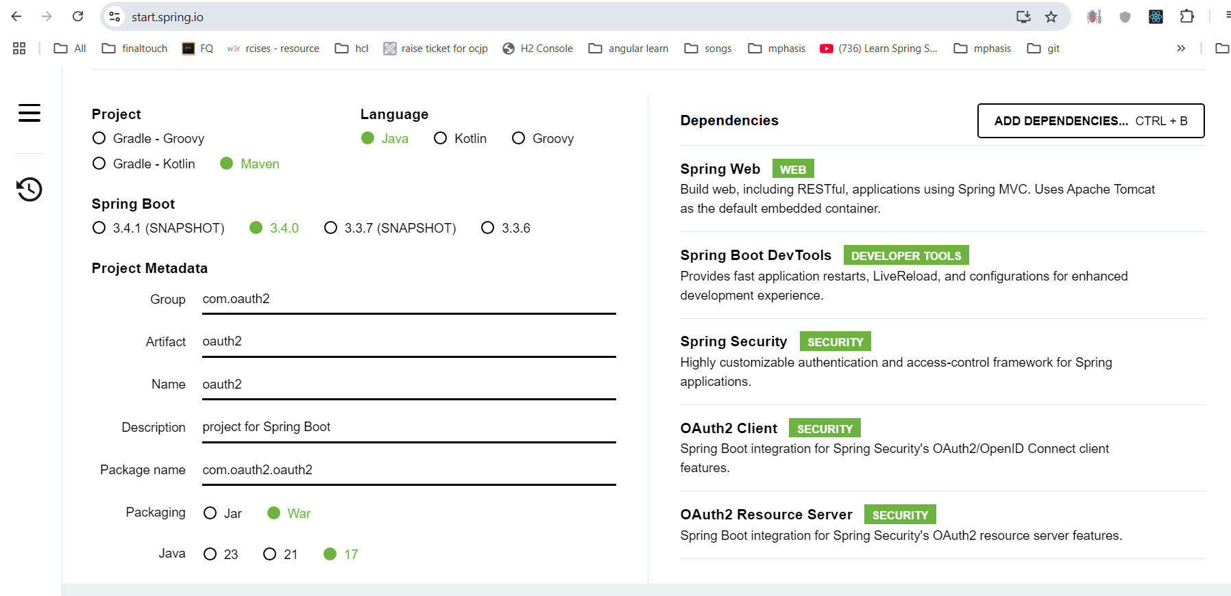

In github🡪settings🡪developersettings🡪oauthapps

